
Artificial Intelligence project

Name : Shaik Azeer saheb
Roll no: B56
Id no: 11805521

SECTION : K18TM

Github link:

Home Automation System using Artificial Intelligence
● Introduction
The general goal of the home automation is to use networking technology to integrate thedevices, appliances and services found in homes so that the entire domestic living space canbe controlled centrally or remotely. Home automation is a very promising area. Its mainbenefits range from increased comfort and greater safety and security, to a more rational useof energy and other resources, allowing for significant savings .It also offers powerful means for helping and supporting the special needs of people with
disabilities and, in particular, the elderly. This application domain is very important and will steadily increase in the future" .
❖ Objective
1) To create a comfortable and hands-free environment in homes.
2) To adapt the proposed AI to the occupants lifestyle.
3) To analyze the methods of home automation.
4) To allow remote communication with home appliances.
5) Save energy.
This application domain is very important and will steadily increase in the future . With
rapid economic growth, living standard are also rising day by day. The modern society wants
safe, economic, comfortable and convenient life which is ideal for every family. By using off
the shelf components to reduce the cost and open source software to get around licensing
requirements of software, we can develop an economical smart home system without
increasing the complexity.
Application of AI in Home Automation
1) Use of AI in Comfortable Systems: In these systems the application of AI is limited asmost of the part can be easily implemented using some electronic circuitry. Here the only partwhere the AI is effective is the knowledge based database which should be learnable for system to be truly comfortable. Since AI tools are little bit costly it will increase the cost ofthe system but will make the system more comfortable, flexible, easy updatable etc.
2) Use of AI in Remote Controlling Systems: In these systems AI can be applied in theauthorizer as well decision maker stage. Applying AI at the authorizer will increase the
responsiveness and security and is more applicable when the environment underconsideration is an industry where security is a major concern . On the other hand, Decision
making part can utilize the case based reasoning of AI for effective and efficient management as it has to decide that which of the target device is corresponding to this particular instruction.
3) Use of AI in Optimizing the Resource Performance: In this system AI for Analyzer as it makes it more efficient in deciding the particular action. Moreover, if analyzer is learnable from its experience then it will make the system more optimized.
4) Use of AI in Secure Systems The biggest use of AI is in these systems. Here we can apply
following tools of AI for various applications:
a) Video Processing for security threat analysis
b) Image Processing for security threat analysis
c) Audio processing for security threat analysis
d) Knowledge base system for Security system database
Natural language processing (NLP)
Natural language processing (NLP) is a field of computer science, artificial intelligence, and computational linguistics concerned with the interactions between computers and human (natural) languages and, in particular, concerned with programming computers to fruitfully process large natural language corpora. Challenges in natural language processing frequently involve natural language
understanding, natural language generation , connecting language and machine perception, managing human-computer dialog systems.
Project Description
The aim of the project is to create a convenient and user friendly environment for the home occupants. It also aims to intelligently coordinate all appliances communicating together, thereby ensuring greater comfort. One suitable programming method for home automation systems is the definition of linguistic rules that can be processed by a fuzzy system.In our approach,
using Natural Language Processing(NLP) the home system adapts itself to the occupants lifestyle and carries out the user's tasks.
Screen Shots:
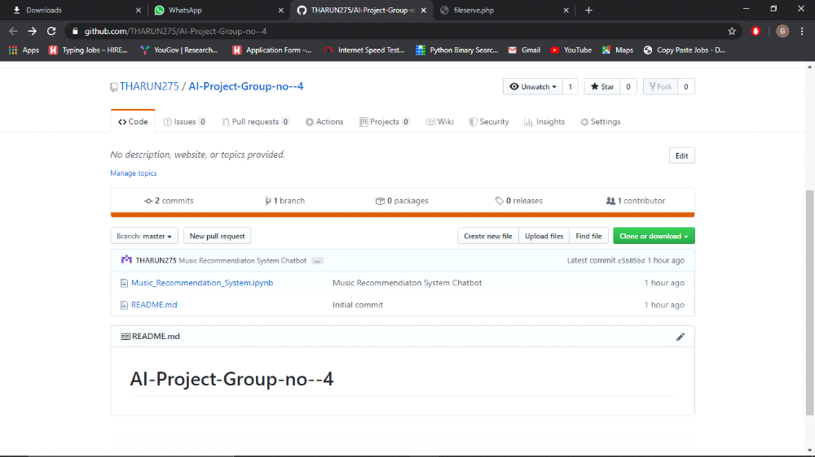

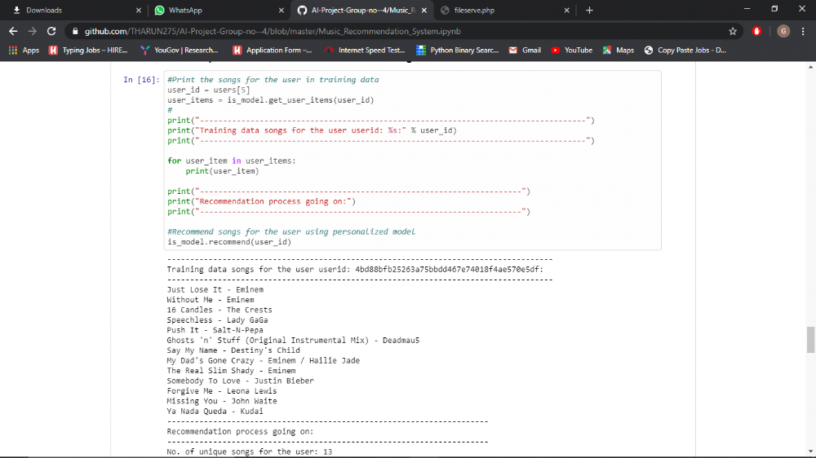

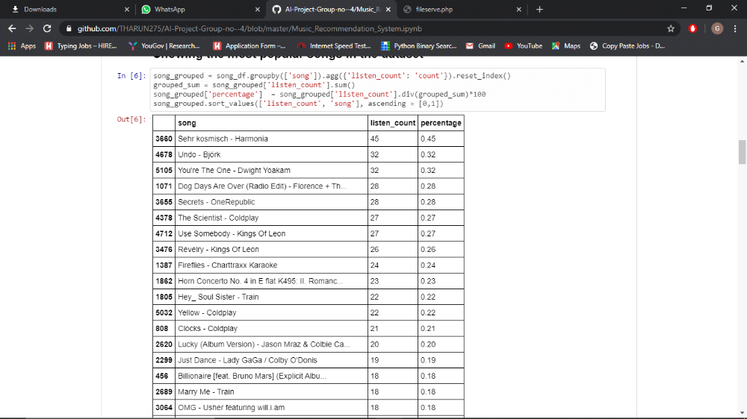

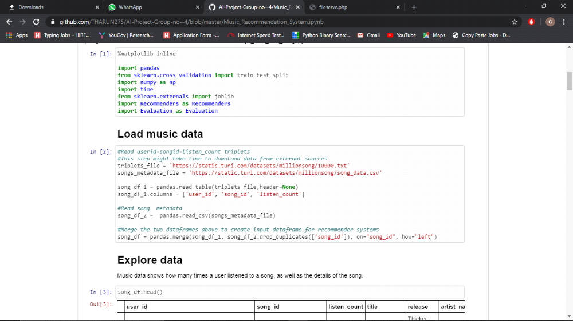
CONCLUSION :-
The Home Automation system provides a centralized control over the home appliances with the addition of low cost devices and an intelligent system.
The introduction of a Personal Assistant, in this case Jasper, has eliminated the need of an additional device like a smartphone or a Bluetooth device. The hands-free control over the appliances provides help and assistance to the disabled and elderly.
With the growth in the field of Home Automation, the main aim of the project is to bring about an Intelligent System to make dayto-day household decisions. Using Natural Language Processing, the users request is executed and acknowledged by the Intelligent System.

